Leafy AI
System Maintenance Document
AI Agent for Sweet Basil Production in a Smart Hydroponic Vertical Farm

Document item | Detail
Project owner | Alex Stumpf — Senior Lecturer, Engineering, La Trobe University
Team | Shallow Mind
Release source | 1 October 2026

Contents
1. Introduction and System Overview | 10. Security, Safety and Risk Management
2. Requirements and Project Context | 11. Known Limitations and Future Development
3. System Design and Technical Rationale | 12. Handover and Maintenance Guidance
4. Software Architecture and Data Flows | 13. References
5. Database Design | Appendix A. Environment Variables
6. API Reference | Appendix B. Operational Command Reference
7. Installation, Configuration and Deployment
8. Operations and Maintenance
9. Testing and Release Validation

1. Introduction and System Overview

1.1 Purpose
Leafy AI is a full-stack monitoring and limited-autonomy platform for a laboratory hydroponic vertical farm growing sweet basil. It combines sensor ingestion, RTSP camera capture and image-quality gating, farm-state assembly, configurable LLM/VLM recommendations, deterministic safety checks, audited fan/light actuation, growth tracking and a React operator dashboard.
This document records the implemented architecture, technical decisions, setup, operation, validation, maintenance and extension guidance required for project handover.

1.2 Current implemented scope
- User registration plus JWT login and refresh-token authentication.
- Direct local-network HTTP ingestion from water-quality and ambient/water-level devices.
- Seven normalised physical sensor streams: pH, EC, water temperature, ambient temperature, relative humidity, dew point and reservoir water level.
- RTSP camera capture with schedule/interval rules and technical VLM image-quality gate.
- AI recommendation runs using configurable LLM/VLM providers, encrypted API credentials, manual execution and scheduled execution windows.
- Deterministic safety validation before automatic actuation.
- Automatic fan and grouped grow-light commands after a passed safety check; pumps, dosers, water and harvest actions remain advisory.
- TP-Link/Kasa powerboard integration with read-back confirmation and FarmAction audit records.
- Docker Compose deployment topology for frontend and backend services.
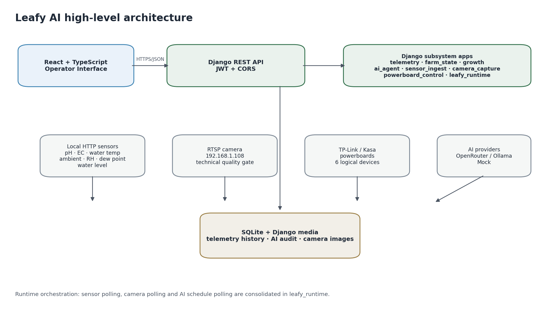
Figure 1. High-level Leafy AI architecture derived from the current repository.

1.3 System boundaries
Inside Leafy AI | Outside / external dependency
Farm data model, sensor history, camera metadata and AI audit trail | Physical sensor firmware and calibration
Sensor HTTP collection and normalisation | Lab LAN availability and device HTTP endpoints
RTSP acquisition and technical image-quality checks | Physical IP camera firmware and stream availability
AI prompt/orchestration, evidence selection, parsing and safety validation | OpenRouter/Ollama model behaviour and availability
Kasa command orchestration and confirmation | TP-Link/Kasa powerboards, outlet wiring and network access
Operator web interface | Browser/device environment and user operational decisions

2. Requirements and Project Context

2.1 Project objective
The project objective is to provide a usable AI-supported farm-management platform that can observe the hydroponic environment, interpret current conditions, explain recommendations, enforce software safety constraints and, for selected low-risk devices, execute validated actions. The system is designed as an incremental path toward autonomous sweet-basil production rather than as an unrestricted autonomous controller.

2.2 Core functional requirements
ID | Requirement | Implemented interpretation
FR-01 | Monitor farm environment | Acquire pH, EC, water temperature, ambient temperature, humidity, dew point and water level from physical sensors and retain history.
FR-02 | Visual monitoring | Capture RTSP images on a configurable interval and store the official image with quality diagnostics.
FR-03 | Farm-state assembly | Expose current device, sensor, camera, batch and trend state to operators and AI services.
FR-04 | AI recommendations | Generate explainable recommendations using VLM input when suitable images exist and sensor-only LLM fallback otherwise.
FR-05 | Safety validation | Apply deterministic policy and evidence checks before any automatic hardware action.
FR-06 | Controlled automation | Permit automatic fan and grow-light changes only after safety pass; keep pump/doser/high-impact recommendations advisory.
FR-07 | Manual device control | Allow authenticated operators to inspect and switch the six logical Kasa-controlled devices.
FR-08 | Growth tracking | Create/manage growing areas and plant batches, track current placement and lifecycle status.
FR-09 | Audit/history | Persist recommendation runs, decisions, safety checks, hardware actions, sensor history and camera quality evidence.
FR-10 | Configuration | Provide runtime-editable sensor-ingest and AI settings without requiring source-code changes.

2.3 Non-functional requirements
- Safety: no AI-generated automatic command should bypass deterministic server-side validation.
- Traceability: preserve evidence, provider/model, safety result and physical action outcome for later review.
- Maintainability: separate acquisition, state interpretation, AI orchestration, safety and hardware control into clear Django apps.
- Resilience: HTTP requests use bounded retries; different SensorIngestConfiguration records are scheduled independently; AI uses bounded retries and VLM-to-LLM fallback; and powerboard actions verify resulting state. Within one sensor configuration, the water-quality and ambient endpoints are currently collected sequentially, so a failure from either source aborts that collection cycle before readings are persisted.
- Security: authenticated REST API, encrypted farm-specific AI credentials, explicit CORS configuration and environment-based secrets.
- Usability: expose current farm state and decisions in a responsive operator dashboard with clear status and manual controls.
- Portability: support Docker Compose deployment and optional local Python/Node maintenance workflows.

3. System Design and Technical Rationale

3.1 Architectural style
Leafy AI uses a React/TypeScript single-page frontend and a Django REST backend. The backend is a modular monolith: domain concerns are separated into Django apps.
Decision | Chosen approach | Technical justification | Trade-off / limitation
Backend architecture | Django 4.2 + Django REST Framework | Strong ORM/migration support, authentication ecosystem, clear app boundaries and rapid API development. | Single backend process couples API availability and background runtime; Django runserver is development-oriented.
Frontend | React 19 + TypeScript + Vite | Component-based dashboard, strong JavaScript team fit, typed API models and fast development server. | Requires separate frontend toolchain and API/CORS configuration.
Database | SQLite in current repository | Low setup overhead and a portable file database suitable for the current laboratory deployment. | Limited concurrency/operational resilience; PostgreSQL is preferable for multi-user production deployment.
Sensor integration | Direct private-LAN HTTP | Avoids cloud relay latency/dependency and maps closely to current physical devices. | Only works when the host can reach the lab network; network/device changes require reconfiguration.
Camera integration | RTSP + OpenCV | Matches the physical IP camera and allows direct frame acquisition plus deterministic technical checks. | RTSP reliability depends on LAN/camera firmware; media storage grows over time.
AI providers | Provider abstraction: OpenRouter, Ollama, Mock | Supports hosted models, local models and deterministic offline testing without coupling business logic to one vendor. | Different models may behave differently; schema validation and fallbacks are required.
Automation policy | Automatic only for fans/lights after safety pass | Reduces impact of model errors while demonstrating closed-loop actuation and preserving human responsibility for higher-risk actions. | The system is not fully autonomous for pumps/dosing/harvest.
Hardware bridge | Synchronous bridge over async python-kasa loop | Lets synchronous Django code safely reuse an asynchronous Kasa controller and centralises board access. | In-process bridge is suitable for current scale but not a distributed command bus.
Runtime scheduling | leafy_runtime workers inside Django runserver | One operational start command and shared application context; avoids duplicate sensor/camera services. | Background work is tied to the web process and should move to a dedicated scheduler/worker for production.

3.2 Separation of responsibilities
Subsystem | Primary responsibility | Explicitly not responsible for
sensor_ingest | Acquire, validate, normalise and persist physical observations. | Crop-safety decisions or hardware actuation.
camera_capture | Acquire official RTSP frames and assess technical image suitability. | Plant-health diagnosis or lighting control.
farm_state | Assemble current state, freshness and trend summaries. | AI model invocation or hardware commands.
ai_agent | Evidence selection, recommendation generation, parsing, safety invocation and audited automatic action orchestration. | Direct unvalidated hardware access.
powerboard_control | Discover/read/write Kasa outlets and confirm physical state. | Deciding whether an action is safe or appropriate.
telemetry | Shared persistent farm, sensor, image and hardware-reference models/API. | Business policy.
growth | Operator workflows for growing areas, plant batches and movement. | Environmental control policy.

3.3 Safety-by-design choices
- Model output is parsed and validated against known categories, targets and farm-device IDs before persistence.
- A recommendation must meet a confidence threshold of 0.70 to pass safety validation.
- Relevant sensor readings must be fresh, numeric and not marked suspect for climate/dosing/water decisions.
- Only fan and grouped-light targets can use execution_type=automated; irrigation pump, nutrient doser and pH doser remain notification-only.
- Fan direction is validated against temperature, humidity and calculated condensation risk.
- Irrigation-duration wording is checked against configured minimum/maximum values when present in recommendations.
- Powerboard commands are followed by hardware state confirmation and an audited FarmAction result of success, partial or failed.
- Scheduled AI runs skip execution when there is no new eligible sensor or camera evidence since a previous completed run.

3.4 Camera quality gate rationale
The VLM is not given every captured frame. A deterministic technical gate first checks whether the image is usable. This separates technical camera quality from plant interpretation and gives a traceable reason when visual evidence is excluded.
Check | Current threshold / behaviour
Resolution | At least 320 × 240.
Blur | Laplacian variance at least 18.0.
Brightness | Mean grayscale between 25 and 235, with under/overexposure limits.
Contrast | Grayscale standard deviation at least 18.0.
Monochrome / IR | Very low saturation and colour-pixel percentage causes FAIL.
Magenta grow-light cast | Produces WARN rather than FAIL; VLM input remains allowed if no other failure exists.
Routing | PASS/WARN → vlm_ready=true; FAIL → vlm_ready=false.

3.5 Alternatives and trade-offs considered
- Direct sensor HTTP replaced the earlier ThingSpeak path. The current design removes external cloud-feed dependency but makes lab-network reachability a deployment requirement.
- React was selected over other frontend framework options considered during planning because it aligned with team JavaScript experience and the component-heavy dashboard design.
- SQLite was retained for the current laboratory deployment instead of introducing PostgreSQL deployment complexity; this is a scalability trade-off rather than a claim of production readiness.
- A provider abstraction was preferred over hard-coding one LLM/VLM vendor. This costs some configuration complexity but improves testability and vendor flexibility.
- The team deliberately stopped short of unrestricted AI actuation. Demonstrating reliable safety-gated fan/light automation was judged more defensible than allowing model-generated dosing/pump commands to operate without additional human/physical safeguards.

4. Software Architecture and Data Flows

4.1 Sensor ingestion flow
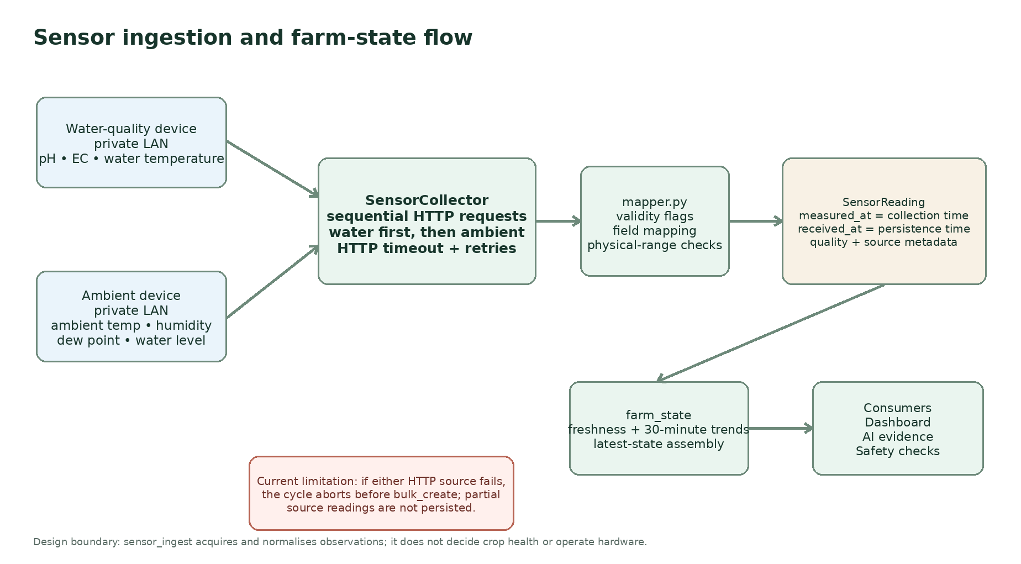
Figure 2. Direct physical-sensor ingestion and downstream farm-state flow.

4.2 Camera and visual-evidence flow
1. leafy_runtime polls camera_capture at the configured interval.
2. camera_capture identifies due, enabled, non-archived RTSP cameras inside their active window.
3. OpenCV obtains the official frame from the configured RTSP stream.
4. quality.assess_image_quality() generates PASS/WARN/FAIL, flags, message and metrics.
5. The JPEG and technical-quality metadata are persisted as telemetry.CameraImage.
6. AI recommendation generation considers the latest image from each enabled camera, filters to PASS/WARN + vlm_ready, applies maximum age and maximum image-count settings, then attempts VLM input.
7. Unreadable or unavailable images cause graceful fallback to the sensor-only LLM path rather than failing the complete recommendation workflow.

4.3 AI decision and actuation flow
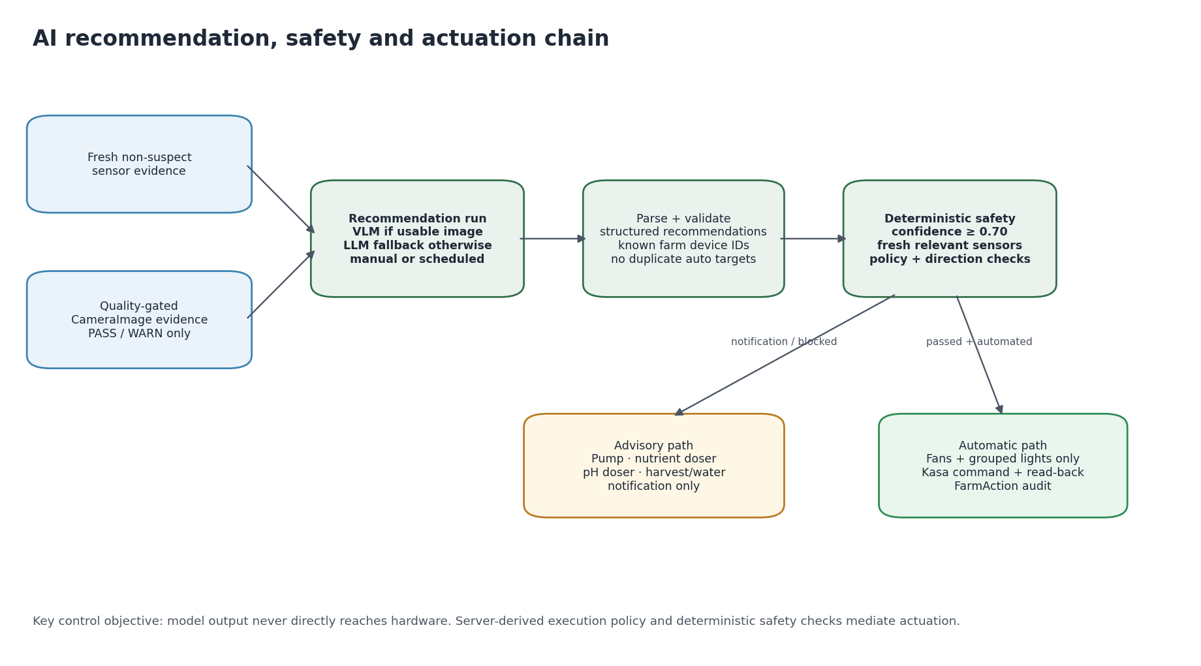
Figure 3. Evidence → recommendation → deterministic safety → audited action/notification.

4.4 Scheduled runtime
Worker | Current behaviour | Failure handling
Sensor scheduler | Polls enabled SensorIngestConfiguration rows at runtime-defined intervals. | A failed collection is recorded for that FarmDevice configuration and later cycles continue. Different due device configurations are processed independently. Within one configuration, either HTTP source failing aborts that cycle before persistence; manual collection uses an operation lock.
Camera worker | Calls the camera due-check/capture service every LEAFY_CAMERA_POLL_SECONDS. | Camera/network failures are caught so the Django process can continue.
AI scheduler | Polls schedule-enabled AIConfiguration rows and creates one run per unique farm/schedule slot. | Duplicate slots are prevented by database constraint; unchanged scheduled evidence is skipped.

4.5 Deployment topology
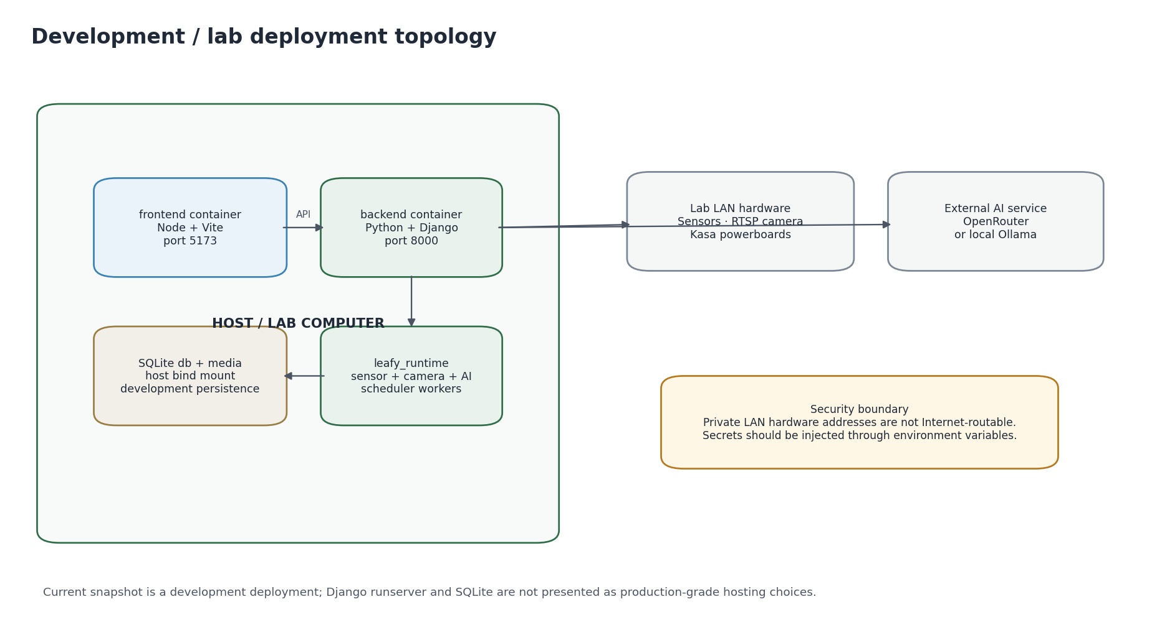
Figure 4. Current Docker Compose and laboratory deployment topology.

5. Database Design
The backend uses Django ORM with SQLite. Migrations and active models are the authoritative schema history. database_schema_v2.md remains a supporting design reference; its legacy ingestion notes are recorded as a known documentation limitation in Section 11.
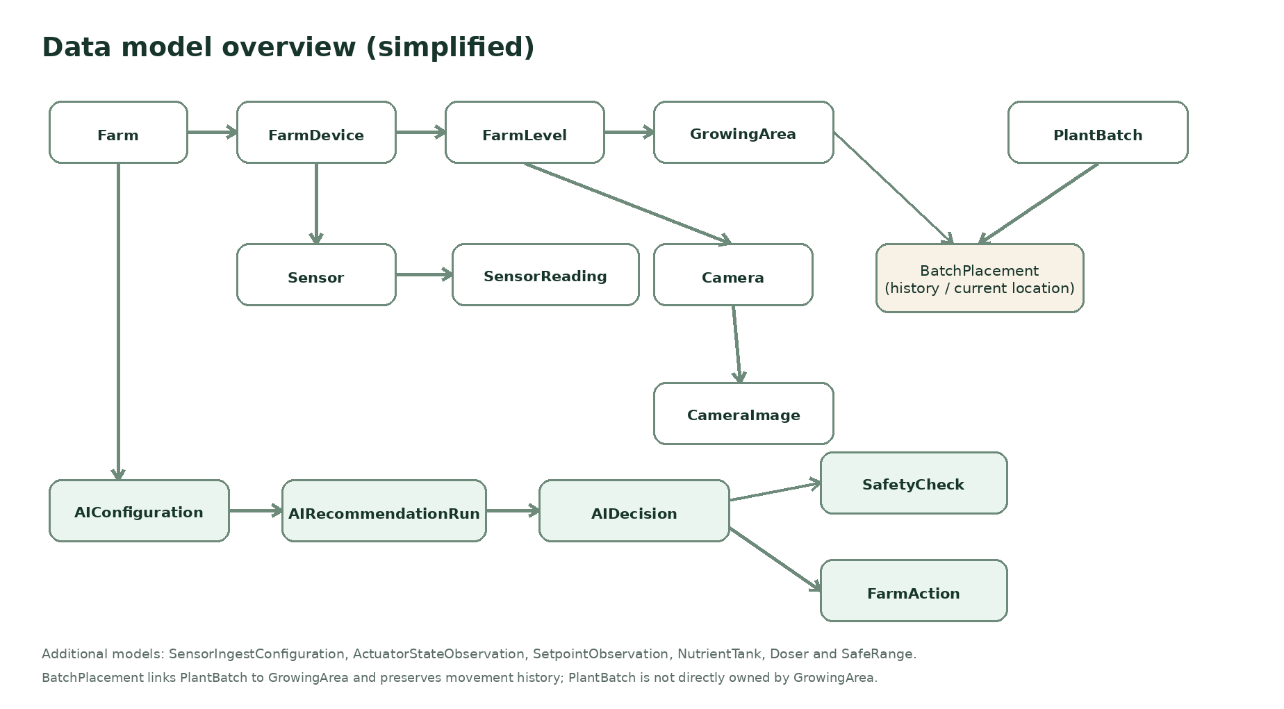
Figure 5. Simplified relationship view of the main persisted entities.

5.1 Entity groups
Group | Models | Purpose
Farm structure | Farm, FarmDevice, FarmLevel, GrowingArea | Represents the physical farm/rack hierarchy.
Crop lifecycle | PlantBatch, BatchPlacement | Tracks basil batches, growth stage, status and location over time.
Visual monitoring | Camera, CameraImage | RTSP configuration, captured media and VLM technical-quality metadata.
Sensors | Sensor, SensorReading | Stable machine slugs, observation time, receipt time, source and quality status.
External observations | ActuatorStateObservation, SetpointObservation | Preserves externally observed state/setpoints separately from commands.
Hardware reference | NutrientTank, Doser, SafeRange | Reference information for farm hardware and safety ranges.
Sensor runtime config | SensorIngestConfiguration | One runtime-editable ingest configuration per FarmDevice.
AI control/audit | AIConfiguration, AIRecommendationRun, AIDecision, SafetyCheck, FarmAction | Provider/schedule configuration, evidence lineage, recommendations, safety and physical outcomes.

5.2 Integrity and audit properties
- FarmLevel is constrained to level 1 or 2 and unique per FarmDevice.
- FarmDevice slugs and Sensor slugs provide stable machine identifiers independent of auto-increment IDs.
- SensorReading stores measured_at separately from received_at. In the current direct-HTTP integration, measured_at is assigned by Leafy AI at collection time because the physical devices do not provide a source-side measurement timestamp; received_at records persistence time. Freshness therefore represents the age of Leafy AI’s latest observation, not independently verified sensor sample time.
- Sensor readings maintain quality_status values valid, unverified or suspect; suspect values are excluded from AI freshness/trend evidence.
- CameraImage is protected from accidental parent deletion and stores deterministic quality evidence used for VLM routing.
- Scheduled AI runs use a unique (farm, scheduled_for) constraint to prevent duplicate execution for one slot.
- SafetyCheck is one-to-one with AIDecision; FarmAction retains the requested, previous and confirmed states plus raw normalized hardware response.

5.3 Migration practice
Do not rewrite or delete migrations already applied to shared databases. New schema changes should be additive forward migrations. Apply migrations before application startup. The Docker backend command currently performs migrate, bootstrap_leafy and runserver in sequence.
python manage.py makemigrations --check --dry-run
python manage.py migrate
python manage.py showmigrations

5.4 Backup and restore
- SQLite database: stop writers, then copy backend/db.sqlite3 to a dated backup location.
- Camera media: back up backend/media/ if historical images are required; the database alone does not contain JPEG bytes.
- Configuration/secrets: back up deployment environment configuration securely and separately from source control.
- Restore: replace the SQLite file only while the application is stopped, restore matching media if required, then run python manage.py migrate.
- For a clean rebuild, delete the local database only when data loss is acceptable, then run migrate and bootstrap_leafy.

6. API Reference
All /api/ endpoints use JWT authentication by default except registration and token login/refresh. The tables below document the public application contract at a maintenance level; serializers in the repository remain the field-level authority.

6.1 Authentication
Method | Endpoint | Purpose
POST | /api/auth/register/ | Create a Django user and return refresh/access JWTs.
POST | /api/auth/login/ | Obtain JWT access and refresh tokens.
POST | /api/auth/refresh/ | Exchange a refresh token for a new access token.

6.2 Core model resources
Resource base | Methods | Notes
/api/farms/ | GET/POST/PUT/PATCH/DELETE | Paginated farm CRUD.
/api/farm-devices/ | CRUD | Farm hardware/controller records.
/api/farm-levels/ | CRUD | Two-level rack model.
/api/growing-areas/ | CRUD | Generic DRF CRUD; growth app also exposes operator workflow endpoints.
/api/plant-batches/ | CRUD | Generic batch CRUD.
/api/batch-placements/ | CRUD | Batch movement history.
/api/cameras/ | GET/POST/PUT/PATCH | List excludes archived cameras; hard DELETE is disabled.
/api/camera-images/ | GET only | Captured image history and quality metadata.
/api/sensors/ | CRUD | Sensor definitions and freshness settings.
/api/sensor-readings/ | GET only | Immutable-style sensor history.
/api/actuator-state-observations/ | GET only | Externally observed actuator state.
/api/setpoint-observations/ | GET only | Externally observed setpoints.
/api/nutrient-tanks/ | CRUD | Nutrient reservoir reference state.
/api/dosers/ | CRUD | Doser calibration/reference records.
/api/safe-ranges/ | CRUD | Database reference ranges; active AI safety currently loads farm_config.yaml.
/api/ai-decisions/ | GET only | Persisted recommendations.
/api/safety-checks/ | GET only | Persisted safety results.
/api/actions/ | GET only | Audited automatic hardware actions.

6.3 Operator and subsystem endpoints
Method | Endpoint | Purpose
GET | /api/farm-state/{farm_id}/ | Complete assembled current farm state.
GET | /api/farms/{farm_id}/dashboard/ | Operator dashboard aggregate.
GET | /api/farms/{farm_id}/sensor-readings/ | Paginated/filterable readings.
GET | /api/farms/{farm_id}/sensor-history/ | Aggregated historical sensor series.
GET/POST | /api/farms/{farm_id}/cameras/ | Farm-scoped camera list/create.
GET/PATCH | /api/farms/{farm_id}/cameras/{camera_id}/ | Farm-scoped camera read/update.
POST | /api/farms/{farm_id}/cameras/{camera_id}/capture/ | Force one camera capture with operation lock.
GET | /api/farms/{farm_id}/camera-images/ | Farm-scoped image gallery.
GET | /api/farms/{farm_id}/sensor-ingest/ | List ingest configurations.
GET/PATCH | /api/farms/{farm_id}/sensor-ingest/{device_id}/ | Read/update one ingest configuration.
POST | /api/farms/{farm_id}/sensor-ingest/{device_id}/test/ | Validate endpoints without storing readings.
POST | /api/farms/{farm_id}/sensor-ingest/{device_id}/collect/ | Run and store a manual collection cycle.
GET | /api/devices/ | Read six logical Kasa device states.
POST | /api/devices/{device_id}/state/ | Request ON/OFF and return confirmed state.
GET/PATCH | /api/ai-agent/farms/{farm_id}/settings/ | Read/update per-farm provider and schedule settings.
POST | /api/ai-agent/farms/{farm_id}/providers/test/ | Test configured LLM or VLM provider.
POST | /api/ai-agent/farms/{farm_id}/recommendations/generate/ | Generate recommendation run now.
GET | /api/ai-agent/farms/{farm_id}/recommendations/latest/ | Latest run.
GET | /api/ai-agent/farms/{farm_id}/recommendations/recent/ | Recent run summaries.
GET | /api/ai-agent/farms/{farm_id}/recommendations/history/ | Paginated/filterable run history.
GET | /api/ai-agent/farms/{farm_id}/recommendations/{run_id}/ | Detailed run/evidence/recommendations.
GET | /api/growing-areas | Growth UI area list.
GET | /api/batches | Growth UI batch list.
PATCH | /api/move-batch | Move batch between areas.
POST/PATCH/DELETE | /api/*growing-area* | Create/update/delete growing-area workflow endpoints.
POST/PATCH | /api/*batch* | Create/update batch workflow endpoints.

7. Installation, Configuration and Deployment

7.1 Deployment environment
Component | Release environment
Host environment | Any environment supported by Docker Compose and able to reach the private lab network.
Python | Backend Docker image uses Python 3.12.
Node.js | Frontend Docker image uses Node 22.
Browser | Modern Chromium/Firefox-class browser.
Network | Lab host must reach sensor HTTP endpoints, RTSP camera and Kasa powerboards on the private LAN.
Storage | SQLite database plus camera media directory; capacity depends on capture frequency/retention.

7.2 Optional backend maintenance setup
python -m venv venv
source venv/bin/activate # Linux/macOS
pip install -r backend/requirements.txt
cd backend
python manage.py migrate
python manage.py bootstrap_leafy
python manage.py check
python manage.py runserver

7.3 Optional frontend maintenance setup
cd frontend
npm ci
npm run dev
# frontend: http://127.0.0.1:5173
# backend: http://127.0.0.1:8000

7.4 Docker Compose deployment
The repository defines two Docker Compose services: backend and frontend. Before startup, copy .env.example to .env, review secrets and hardware/network values, then build and start the stack. The backend reads the root .env file; the frontend runs Vite on port 5173.
cp .env.example .env
# Review .env before starting.
docker compose build
docker compose up
docker compose ps
Dockerfile maintenance note
The frontend image uses Node 22 and Compose serves Vite on port 5173. For deterministic dependency installation and clearer image metadata, future maintenance should prefer npm ci and EXPOSE 5173. The backend image currently installs libpq-dev and gcc; add further system libraries only when required by runtime dependencies.

7.5 Bootstrap behaviour
python manage.py bootstrap_leafy creates or updates the configured Farm, FarmDevice, two FarmLevel rows, seven sensor definitions, SensorIngestConfiguration and configured Camera where applicable. It is repeatable so a fresh database can reach a known structural baseline.

7.6 Post-deployment checks
After deployment or material environment changes, confirm the following before normal operation.
Acceptance check | Expected outcome | Method
Docker image build | Backend and frontend images build without errors. | docker compose build
Docker startup | Django and Vite services start and remain running. | docker compose up / docker compose ps
Database initialisation | Migrations and bootstrap_leafy complete without errors. | Backend startup logs
Application smoke test | Login, Farm Overview and core API calls are reachable. | Browser/API smoke test
Lab integration | Sensor HTTP, RTSP camera and supervised fan/light control respond on the lab network. | Controlled hardware smoke test

8. Operations and Maintenance

8.1 Normal startup sequence
1. Load deployment environment variables.
2. Apply database migrations.
3. Run bootstrap_leafy to ensure the configured farm structure exists.
4. Start Django. leafy_runtime starts sensor/camera/AI scheduler workers only in the runserver process when enabled.
5. Start the React frontend or frontend container.
6. Verify sensor freshness, camera status, AI provider configuration and powerboard reachability before relying on automation.

8.2 Routine maintenance tasks
Frequency | Task
Each deployment | Run migrations, Django check, frontend build, automated tests and smoke tests.
Before farm operation | Confirm private-LAN IPs, camera RTSP path, Kasa outlet mapping and physical labels.
Weekly during active trials | Review sensor-ingest failures, stale sensor trends, failed camera captures, failed/partial FarmActions and AI run errors.
Periodically | Back up SQLite and required media; remove unnecessary old camera images according to an agreed retention policy.
Dependency update | Review Python/npm changes, licences and security advisories before upgrading; rebuild containers and rerun tests.
Hardware change | Update configuration and verify with manual test endpoints before re-enabling scheduled operation.

8.3 Logging and operational evidence
- sensor_ingest uses a dedicated console logger with SENSOR_INGEST_LOG_LEVEL.
- leafy_runtime prints worker startup/restart errors to the backend console.
- AIRecommendationRun persists status, provider/model, evidence IDs, fallback reason, errors, skip reason and timestamps.
- SafetyCheck persists pass/fail explanation for each AIDecision.
- FarmAction persists attempted/executed timestamps, physical device IDs, previous/requested/confirmed states and hardware response.
- CameraImage persists technical quality metrics/flags for later diagnostics.

8.4 Update and patch procedure
1. Create a feature/fix branch; do not experiment directly on the deployment branch.
2. Pull latest changes and review migrations, environment-variable changes and hardware mapping changes.
3. Install/update dependencies in an isolated environment or rebuild images.
4. Run migration dry-run/checks and automated test suites.
5. Back up the current database/media before applying production-like schema changes.
6. Apply migrations and bootstrap only after review.
7. Perform controlled sensor, camera and fan/light smoke tests.
8. Merge only after documented verification and rollback plan.

8.5 Troubleshooting guide
Symptom | Likely cause | Action
No sensor readings | Host not on Lab LAN; endpoint URL wrong; config disabled; device offline. | Use sensor-ingest test endpoint, ping/check HTTP URL, inspect SensorIngestConfiguration last_error and retry settings.
Readings present but AI excludes them | Reading stale, suspect or sensor disabled. | Inspect measured_at, quality_status and stale_after_seconds. For current direct-HTTP ingestion, measured_at is Leafy AI collection time rather than a device-supplied timestamp.
Camera no image | RTSP unreachable, credentials/path wrong, outside active window or camera archived/disabled. | Test RTSP directly, force capture endpoint, inspect camera configuration.
Camera image is FAIL | Low resolution, blur, exposure, contrast or monochrome/IR. | Inspect CameraImage quality_flags and metrics; correct camera focus/exposure/mode.
AI uses LLM instead of VLM | No recent PASS/WARN vlm_ready image, unreadable media, VLM provider failure. | Inspect visual_evidence/fallback_reason on recommendation run.
AI run skipped | Scheduled slot has no new eligible evidence. | Expected behaviour; inspect input_freshness_summary.
Powerboard shows ERROR | LAN/credentials/device discovery/child index issue. | Verify board IP, credentials, Kasa reachability and physical outlet mapping.
FarmAction partial | Grouped-light command succeeded on only one outlet. | Check action hardware_response and individual outlet/network state before retry.
Frontend cannot call backend | Incorrect VITE_BACKEND_BASEURL/CORS or token expired. | Confirm backend URL, CORS_ALLOWED_ORIGINS and JWT refresh behaviour.

9. Testing and Release Validation

9.1 Test strategy
Testing is split across model/API tests, deterministic subsystem tests, frontend component tests and controlled live-hardware smoke tests. Automated tests document expected behaviour but cannot replace physical verification of network addresses, outlet wiring, camera stream paths and sensor calibration.

9.2 Automated and subsystem coverage
Area | Repository coverage
Backend automated tests | Backend tests cover models, APIs, schedulers, safety logic, hardware-action auditing and core workflows.
Frontend automated tests | Frontend Vitest coverage is limited to basic smoke/component tests; expand it before significant UI changes.
Camera | Schedule, multi-camera batch behaviour and five quality-gate scenarios.
Sensor ingestion | Seven-sensor mapping, validity flags, physical-domain suspect values, persistence and repeatable seeding. Partial persistence when one HTTP source fails is not covered because the current collector aborts that cycle.
AI agent | VLM/LLM routing, fallback/retries, safety-gated automation, provider failure handling, scheduler de-duplication and Kasa action audit.
Operator API | Farm scoping, sensor config, manual collection conflict, history aggregation, camera CRUD/capture/gallery, AI history and evidence freshness.
Telemetry/auth/growth | Model constraints, bootstrap, read-only history APIs, registration/password behaviour and growth-area workflows.

9.3 Release validation commands
cd backend
python manage.py check
python manage.py makemigrations --check --dry-run
python manage.py test
python -m pytest camera_capture/tests -v
cd ../frontend
npm ci
npm run test -- --run
npm run build
npm run lint
npm audit
cd ..
docker compose build
docker compose up

9.4 Controlled farm smoke-test sequence
1. Validate sensor endpoints using POST .../sensor-ingest/{device_id}/test/ without storing data.
2. Run one stored collection cycle and confirm all expected sensors update with plausible values/timestamps.
3. Force one camera capture and confirm CameraImage, file storage, PASS/WARN/FAIL fields and media URL.
4. Read all Kasa device states. Physically verify device IDs before sending commands.
5. Toggle a fan or light manually and confirm physical state plus API read-back. Do not use dosers/pump as the first test.
6. Generate one manual AI recommendation and inspect evidence, provider/model, safety result and any FarmAction.
7. Enable scheduled automation only after the above steps are confirmed and supervision is present.

10. Security, Safety and Risk Management

10.1 Security controls implemented
- Django REST Framework requires JWT authentication by default; registration/login/refresh are explicit exceptions.
- CORS is constrained to configured origins and API routes.
- Django password validators are enabled and registration uses create_user so passwords are hashed.
- Per-farm AI API keys are encrypted with Fernet using AI_SETTINGS_ENCRYPTION_KEY before storage.
- Sensor-ingest configuration validates private-LAN HTTP(S) endpoints and prevents arbitrary credential-bearing/public endpoint configuration.
- Secrets can be injected through process/container environment variables rather than committed to source.
- Camera and sensor hardware live on private LAN addresses rather than public Internet addresses.
- Automatic actuation is limited to specific low-risk logical targets and audited after state confirmation.

10.2 Security hardening required for production-like deployment
- Set DJANGO_DEBUG=false and supply a unique high-entropy DJANGO_SECRET_KEY; do not rely on the development fallback.
- Serve the frontend/API behind HTTPS and a production WSGI/ASGI server rather than Django runserver.
- Move from SQLite to a managed/secured database if concurrent multi-user operation or higher availability is required.
- Implement farm/object-level authorisation before any untrusted multi-user deployment. JWT authentication is enforced, but Farm currently has no ownership/membership model and generic DRF querysets are not scoped by request.user; authenticated users are effectively treated as trusted operators across exposed farm records. Hazardous controls should also use explicit operator roles/permissions.
- Add server-side emergency-stop semantics if an atomic all-off guarantee is required; the current frontend E-Stop sends individual OFF commands to the logical devices.
- Introduce centralised structured logging/monitoring and alerting for sensor failure, camera failure, AI failures and partial hardware actions.
- Define backup retention, media retention, credential rotation and incident-response procedures with the project owner.

10.3 Risk register
Risk | Impact | Consequence | Mitigation
Incorrect physical outlet mapping | High | A command could actuate the wrong device. | Keep mapping version-controlled; verify IDs/labels physically before enabling automation; first smoke-test only fan/light.
Stale or invalid sensor evidence | High | Unsafe or misleading recommendation. | Freshness threshold, suspect exclusion, measured_at semantics, relevant-sensor safety checks.
AI malformed/incorrect output | High | Wrong recommendation or metadata. | Schema parsing/validation, retry policy, confidence threshold, deterministic safety, limited automated targets.
Partial grouped-light command | Medium | One level differs from intended state. | Per-device execution, partial FarmAction result, hardware response audit.
Camera poor quality | Medium | VLM visual interpretation is unreliable. | Deterministic image-quality gate and LLM fallback.
LAN or device outage | Medium | Missing sensor/camera/control availability. | HTTP retries, per-configuration failure isolation, stale/missing status and operator visibility; future work should add independent per-source persistence within one sensor configuration.
External AI provider outage/rate limit | Medium | Recommendation generation delayed/fails. | Retryable provider errors, fallback from VLM to LLM, mock/local provider option.
SQLite corruption/concurrency | Medium | Loss/unavailability of local state. | Regular backups; stop writers for copies; migrate to PostgreSQL for production-like use.
Secret exposure | High | Unauthorized provider or application access. | Environment injection, encrypted per-farm keys, placeholder example values, credential rotation.

10.4 Dependency, licence and vulnerability maintenance
Dependency security is an ongoing maintenance activity. Run npm audit for the frontend and pip-audit for backend dependencies when versions change or as part of a maintenance release. Review findings, update deliberately, rebuild containers and rerun tests. Django 4.2 lifecycle and the unpinned python-kasa dependency are tracked below as maintenance priorities.

10.5 Direct dependency and licence register
The following tables list key direct dependencies, their repository constraints or resolved versions, purpose and licence. Recheck licence and vulnerability information when dependencies are updated.
Backend dependency | Version / constraint | Purpose | Licence
Django | 4.2.30 | Web framework / ORM / migrations | BSD-3-Clause
djangorestframework | 3.16.1 | REST API framework | BSD
django-cors-headers | 4.9.0 | CORS middleware | MIT
djangorestframework-simplejwt | 5.5.1 | JWT authentication | MIT
requests | 2.32.5 | HTTP sensor/provider requests | Apache-2.0
Pillow | 11.3.0 | Image processing/storage support | MIT-CMU
PyJWT | 2.13.0 | JWT implementation | MIT
PyYAML | 6.0.2 | farm_config.yaml parsing | MIT
python-kasa | Unpinned | TP-Link/Kasa device control | GPL-3.0-or-later
numpy | >=1.26,<3 | Numerical/image processing support | BSD-3-Clause + bundled compatible licences
opencv-python-headless | >=4.8,<5 | RTSP frame capture / quality metrics | Apache-2.0
cryptography | >=43,<47 | Fernet encryption for stored AI credentials | Apache-2.0 OR BSD-3-Clause
pytest | >=8,<9 | Backend/camera tests | MIT
asgiref | 3.11.1 | ASGI utilities used by Django | BSD-3-Clause
sqlparse | 0.5.5 | SQL parsing dependency | BSD
typing_extensions | 4.16.0 | Typing compatibility | PSF-2.0

Key frontend/runtime dependencies
Frontend dependency | Resolved version | Purpose | Licence
React / react-dom | 19.2.8 | Operator UI | MIT
react-router | 8.3.0 | Client-side routing | MIT
react-icons | 5.7.0 | UI icons | MIT
Tailwind CSS / @tailwindcss/vite | 4.3.3 | Styling/build integration | MIT
Vite | 8.1.5 | Frontend build/dev server | MIT
TypeScript | 6.0.3 | Static typing / compilation | Apache-2.0
Vitest | 4.1.10 | Frontend test runner | MIT
Playwright | 1.62.0 | Browser-test infrastructure | Apache-2.0
ESLint | 10.8.0 | Frontend static analysis | MIT

Dependency maintenance priorities
Maintenance item | Release consideration | Maintenance guidance
Frontend dependency audit | npm audit is the standard frontend dependency audit command. | Run after dependency changes; review findings before upgrades and rerun tests/build.
Backend dependency audit | pip-audit can audit the backend requirements/image environment. | Run after dependency changes; record actionable findings and rerun backend tests.
Django lifecycle | Django 4.2 is outside upstream support. | Upgrade to a supported Django release before long-term production-like operation.
python-kasa versioning | requirements.txt leaves python-kasa unpinned. | Pin a tested compatible version or range after hardware regression testing.

11. Known Limitations and Future Development
Current limitation | Impact / recommended future work
Frontend landing page is a placeholder. | Redirect / to authentication/Farm Overview or replace the placeholder in a future UI release.
Awaiting Decisions Accept/Decline callbacks are not implemented. | The controls currently use empty callbacks. Remove them or implement a persisted approval workflow in a future release.
SQLite + Django runserver development deployment. | Suitable for the current laboratory deployment; move to PostgreSQL plus a production WSGI/ASGI server and reverse proxy for sustained multi-user operation.
Background workers run in the Django process. | Move sensor/camera/AI scheduling to a dedicated worker/scheduler for higher reliability and scaling.
E-Stop is frontend-orchestrated across individual device commands. | Introduce a backend emergency-stop endpoint, priority lockout and hardware-safe-state design if an atomic all-off guarantee is required.
Pump/doser automation is intentionally disabled. | Future automation requires stronger interlocks, calibrated dosing models, trend confirmation, approval policy and physical fail-safe review.
Supporting ingestion documentation is stale. | database_schema_v2.md and sensor_ingest/README.md contain legacy descriptions. Treat active source and migrations as authoritative until those files are reconciled.
Growth/batch status contract is inconsistent. | Backend growth responses translate active/harvested/failed to Growing/Ready/Terminated while the frontend also checks active/completed/Growing. Batch creation currently sends form.growthStage as status. Standardise the API contract and correct the form payload.
Growth page placeholder arrays can fail above five items. | new Array(5 - count) can receive a negative length. Guard with Math.max(0, 5 - count) or render placeholders without a fixed-array assumption.
Dead magenta-light control API remains in the frontend. | Remove /api/lighting/magenta/state/, MagentaState, getMagentaState() and setMagentaState(). Keep camera MAGENTA_CAST image-quality detection.
Farm/object-level authorisation is not implemented. | JWT protects endpoints, but authenticated users are treated as trusted operators and generic querysets are not farm-owner scoped. Add Farm membership/roles before untrusted multi-user use.
Root README is missing and frontend/README.md is effectively empty. | Future repository maintenance should add a root README aligned with this SMD for setup, configuration, tests, Docker and known limitations.
Frontend automated coverage is minimal. | Only two example Vitest tests are present. Add tests for authentication, farm selection, growth status handling, critical settings and error states.

12. Handover and Maintenance Guidance

12.1 Maintainership principles
- Preserve app boundaries: acquisition, interpretation, AI, safety and hardware control should remain distinct.
- Do not bypass SafetyCheck when introducing new automated targets.
- Treat stable slugs and farm-scoped APIs as integration contracts; avoid exposing database IDs as hardware identities where a slug/explicit mapping exists.
- Keep physical mappings and thresholds reviewable and version-controlled; verify them with the project owner after hardware changes.
- Add forward migrations rather than editing applied migration history.
- When changing sensor or camera schemas, update the frontend types, API serializers, SMD and database schema together.
- Use branches/pull requests for integration work and keep generated databases/media/archives out of source control.

12.2 Maintenance lessons and design constraints
- Camera, sensor, AI and powerboard integrations depend on explicit interfaces and clear subsystem ownership.
- Keep camera quality decisions traceable through stored metrics and reasons so VLM routing and hardware diagnostics remain explainable.
- Collection time and receipt time should remain separate. The current local-HTTP hardware does not expose source measurement timestamps, so maintainers must not describe measured_at as independently verified sensor sample time.
- Expand AI autonomy incrementally; keep dosing and pump control behind stronger interlocks and approval policies until validated.
- A consolidated runtime simplifies the current deployment but also shows why larger deployments normally separate web serving from scheduled or long-running workers.
- Keep supporting documentation synchronized with active code and migrations. Where a conflict exists, active source and migration history are authoritative.

12.3 Release handover package
- Release source: retain the source snapshot corresponding to this document together with the committed migration history.
- Configuration: use .env.example as the non-secret template and transfer operational credentials through an approved secure channel.
- Operational records: maintain current sensor/camera endpoints, Kasa outlet mappings and hardware labels with the project records; recheck them after hardware changes.
- Change control: use Section 9 validation commands and smoke tests after material software, dependency, configuration or hardware changes.
- Data continuity: transfer the current SQLite database and required media backup when historical operational data must be preserved.
- Known limitations: Section 11 is the authoritative maintenance backlog for the released system and should be reviewed before major extension work.

13. References
- Leafy AI source repository snapshot: Capstone-LeafyAi-main (18).zip, reviewed 1 October 2026.
- Leafy AI internal files reviewed: backend/sensor_ingest/README.md; backend/camera_capture/README.md; backend/farm_config.yaml; database_schema_v2.md; docker-compose.yml; frontend/package-lock.json; backend/requirements.txt; .env.example.
- Django, Django REST Framework and Simple JWT documentation for the versions listed in Section 10.5.
- React, Vite and Docker Compose documentation for the versions and deployment approach used by this release.
- OpenCV and python-kasa documentation for camera acquisition and TP-Link/Kasa hardware integration.

Appendix A. Environment Variables
Variable | Secret? | Purpose
VITE_BACKEND_BASEURL | No | Frontend API origin.
DJANGO_SECRET_KEY | Yes | Django signing secret; must be overridden outside development.
DJANGO_DEBUG | No | Development debug flag.
DJANGO_ALLOWED_HOSTS | No | Allowed backend hostnames.
CORS_ALLOWED_ORIGINS | No | Allowed browser origins.
OPENROUTER_BASE_URL | No | OpenAI-compatible provider base URL.
OPENROUTER_API_KEY | Yes | Default hosted AI provider credential.
AI_PROVIDER / OPENROUTER_MODEL | No | Default LLM provider/model.
VLM_PROVIDER / VLM_MODEL | No | Default VLM provider/model.
VLM_REQUEST_TIMEOUT_SECONDS | No | VLM request timeout.
AI_SETTINGS_ENCRYPTION_KEY | Yes | Fernet key encrypting stored farm AI credentials.
LEAFY_AI_SCHEDULER_ENABLED | No | Enable recommendation schedule polling.
LEAFY_AI_POLL_SECONDS | No | AI scheduler poll interval.
LEAFY_FARM_NAME / LEAFY_FARM_LOCATION | No | Bootstrap Farm values.
LEAFY_DEVICE_NAME / LEAFY_DEVICE_TYPE | No | Bootstrap FarmDevice values.
SENSOR_INGEST_DEVICE_SLUG | No | Bootstrap device to receive ingest defaults.
LEAFY_WATER_QUALITY_URL | No* | Private-LAN water sensor URL; operationally sensitive but not an Internet secret.
LEAFY_AMBIENT_SENSOR_URL | No* | Private-LAN ambient/water-level URL.
SENSOR_INGEST_POLL_SECONDS | No | Default collection interval.
SENSOR_INGEST_SENSOR_STALE_SECONDS | No | Default stale threshold.
SENSOR_INGEST_HTTP_TIMEOUT_SECONDS | No | HTTP timeout.
SENSOR_INGEST_HTTP_RETRY_TOTAL / BACKOFF | No | HTTP retry behaviour.
SENSOR_INGEST_FAILURE_BACKOFF_* | No | Failure backoff controls.
SENSOR_INGEST_LOG_LEVEL | No | Sensor logger level.
LEAFY_CAMERA_TIMEZONE | No | Camera scheduling timezone.
LEAFY_CAMERA_POLL_SECONDS | No | Camera runtime polling interval.
LEAFY_CAMERA_JPEG_QUALITY | No | JPEG encode quality.
LEAFY_CAMERA_WARMUP_FRAMES | No | Frames skipped before official capture.
FARM_CAMERA_USER / FARM_CAMERA_PASSWORD | Yes if used | RTSP camera credentials.
LEAFY_CAMERA_1_* | No | Bootstrap camera name/level/IP/RTSP path/interval/enabled.
LEAFY_POWERBOARD_1_IP / LEAFY_POWERBOARD_2_IP | No* | Private-LAN Kasa board addresses.
LEAFY_KASA_USERNAME / LEAFY_KASA_PASSWORD | Yes if required | Kasa authentication.
LEAFY_KASA_DISCOVERY_TIMEOUT | No | Device discovery timeout.
LEAFY_KASA_RETRIES / RETRY_DELAY_SECONDS | No | Kasa retry behaviour.
LEAFY_RUNTIME_ENABLED | No | Enable consolidated background workers.
FARM_STATE_SENSOR_TREND_WINDOW_MINUTES | No | Trend aggregation window.

Appendix B. Operational Command Reference
Purpose | Command
Backend release checks | python manage.py makemigrations --check --dry-run && python manage.py migrate && python manage.py bootstrap_leafy && python manage.py check && python manage.py test
Camera tests | python -m pytest camera_capture/tests -v
Frontend release checks | npm ci && npm run test -- --run && npm run build && npm run lint
Docker build/start | docker compose build && docker compose up

